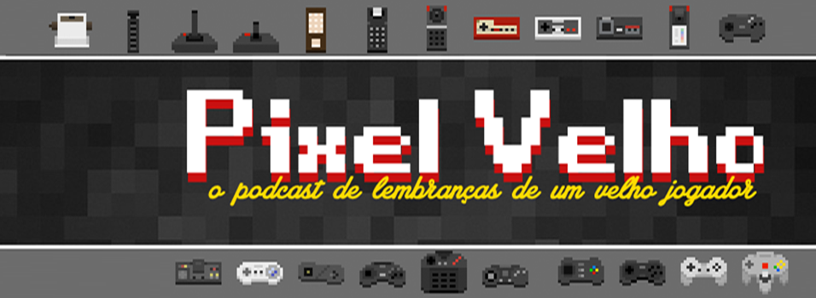
JOGOS DE LUTA SÉRIE B
Participantes
- Jairo Vieira
- Leozito
- Daniel Nascimento
- Miguel Manrubia
- Bira Neves
- Gui Oliveira
Abertura: Apresentação dos Participantes
Tempo livre para apresentações
Tema e Pauta principal: JOGOS DE LUTA SÉRIE B

- (1993) Battle Blaze https://www.youtube.com/watch?v=8h6mHIqeyqE
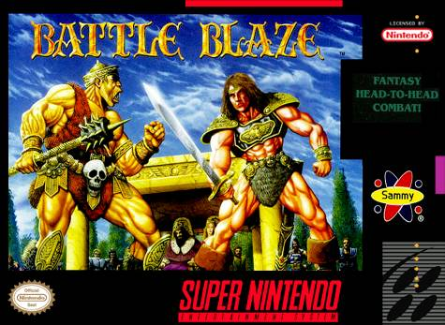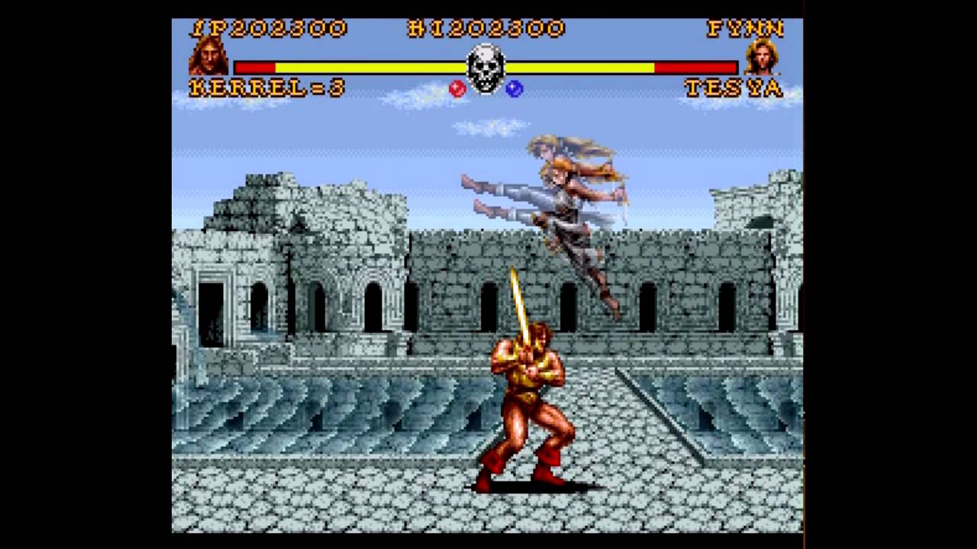

- (1993) ClayFighter https://www.youtube.com/watch?v=KA0wXXsvqkc
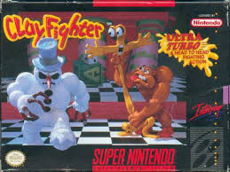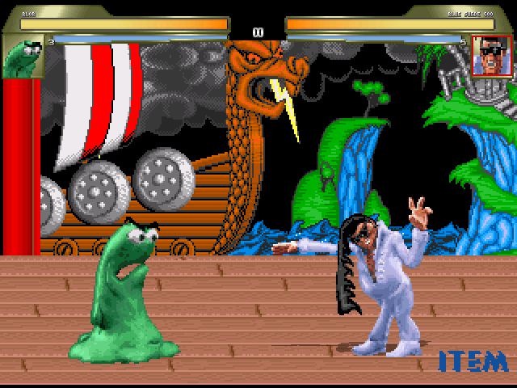

- (1994) Double Dragon V - The Shadow Falls https://www.youtube.com/watch?v=j6fNTlMRdGQ
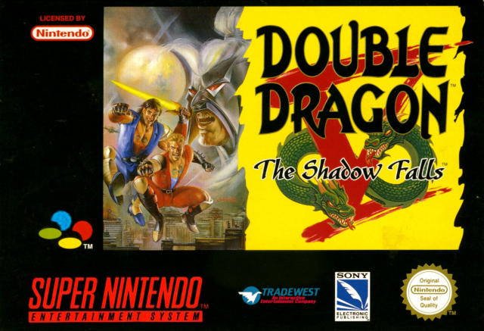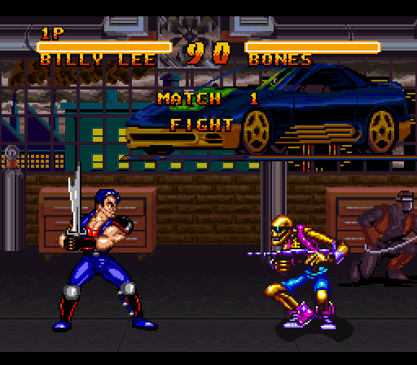

- (1993) Dragon - The Bruce Lee History https://www.youtube.com/watch?v=PkjUcAhJ2jE
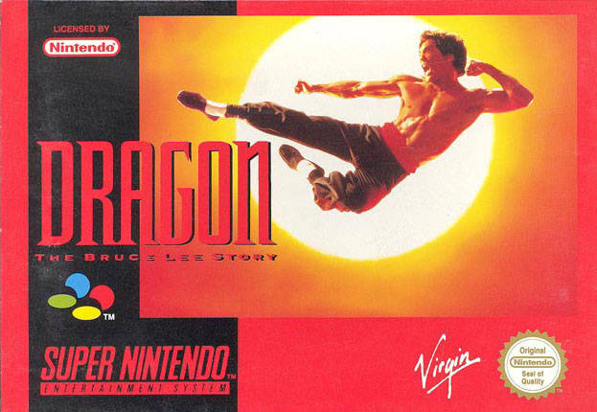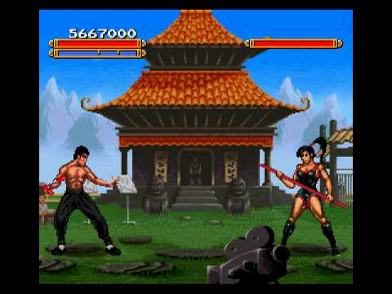

- (1995) Dragon Ball Z
https://www.youtube.com/watch?v=TpJaXzDrTFk
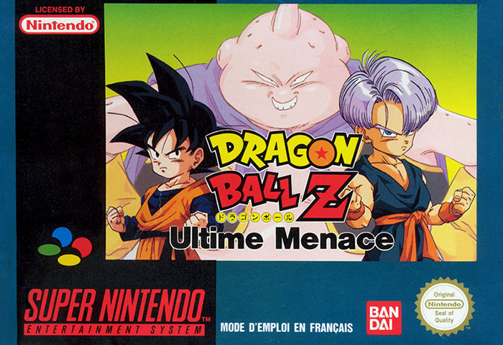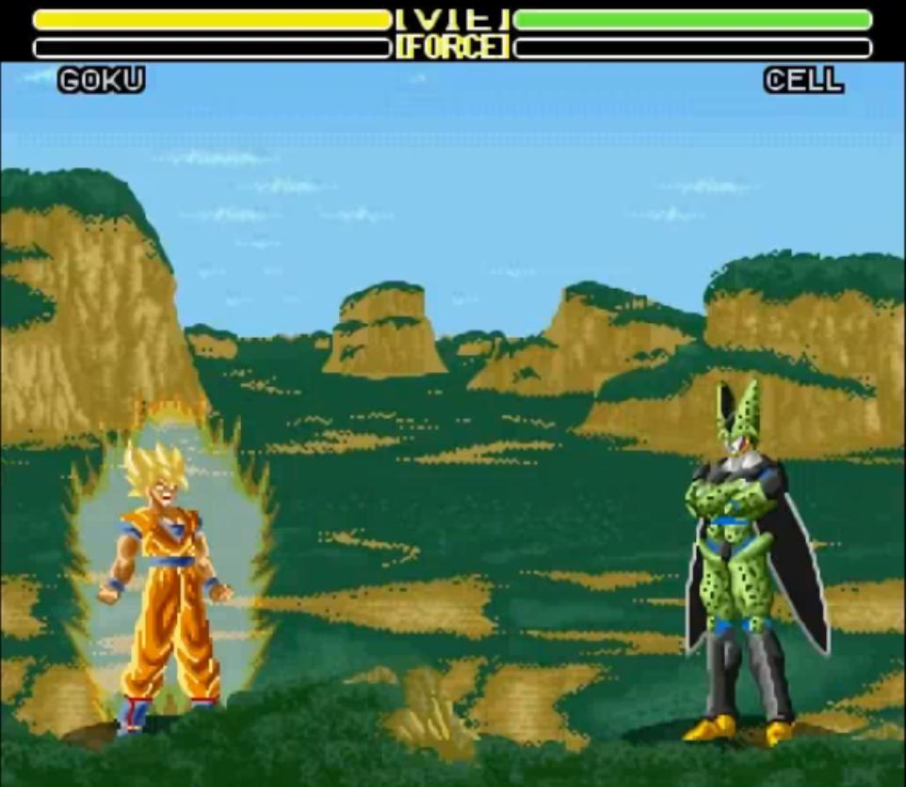

- (1993) Fist of The North Star - Hokuto No Ken 7
https://www.youtube.com/watch?v=Go7KFK5OB6A
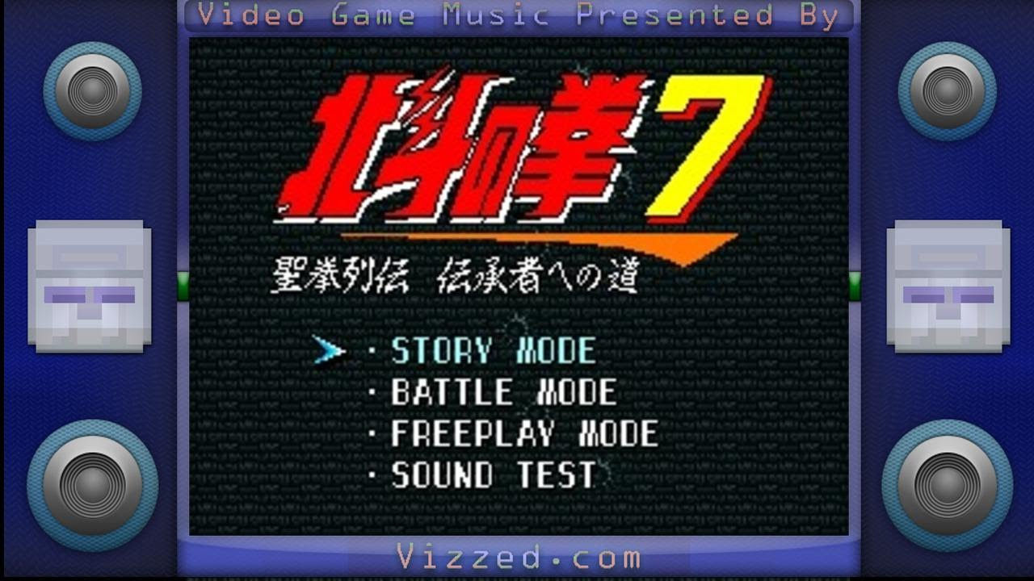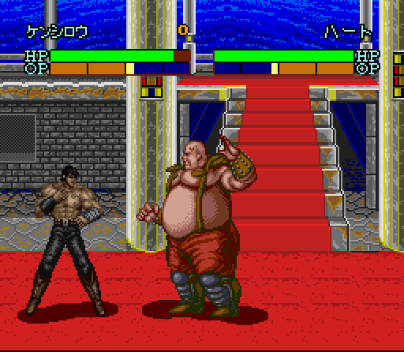

- (1995) Justice League Task Force
https://www.youtube.com/watch?v=VJgY9BCYP8o
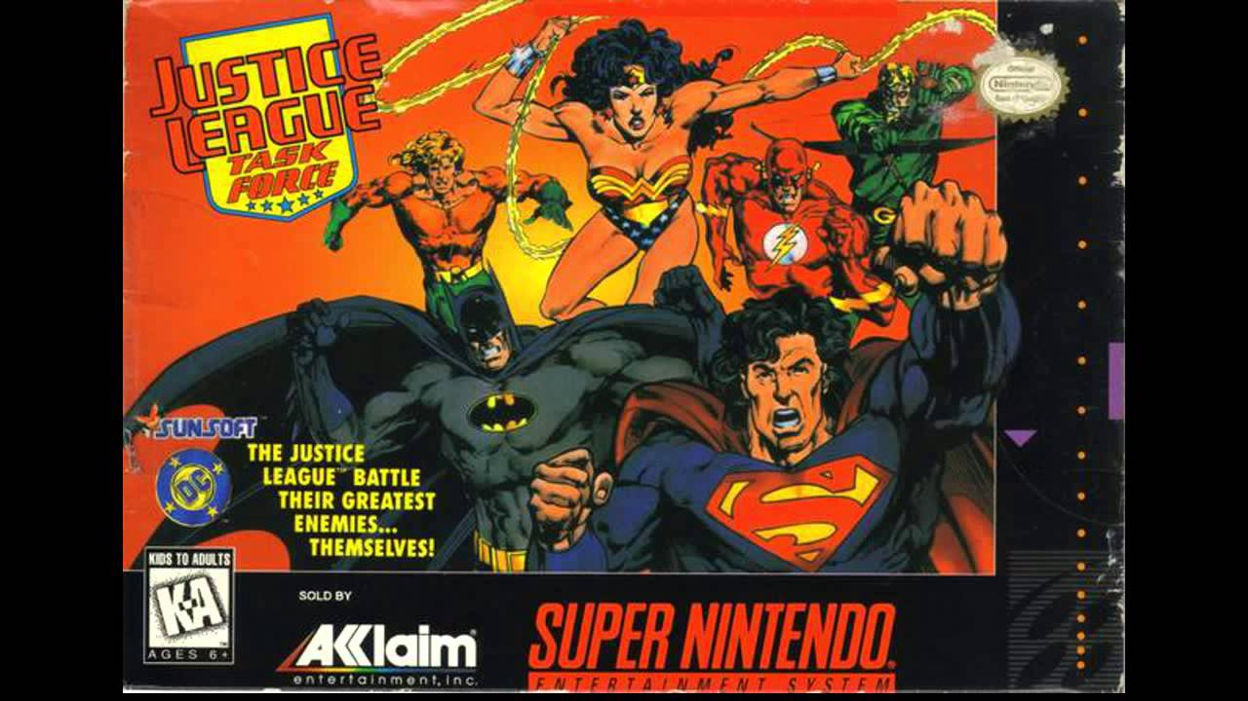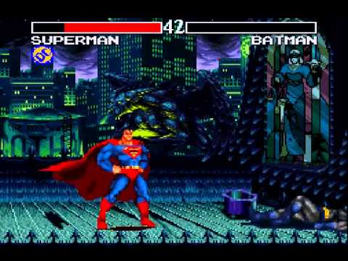

- (1994) Killer Instinct
https://www.youtube.com/watch?v=FVB8fu0e8Yg
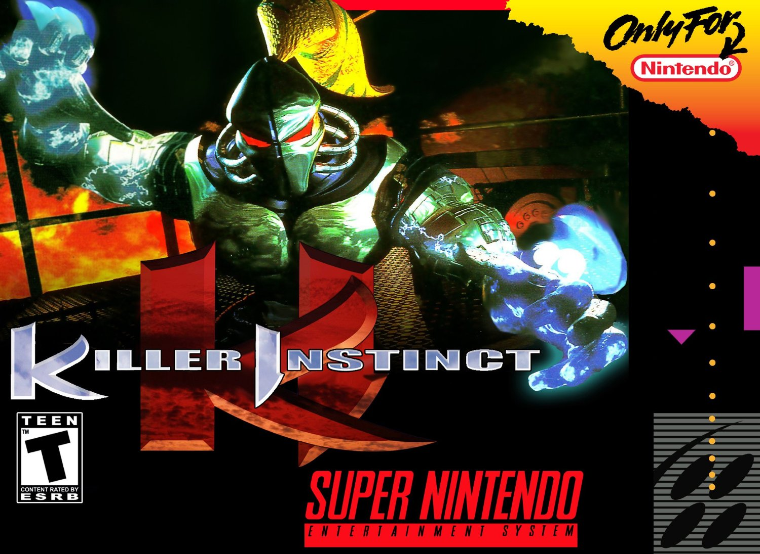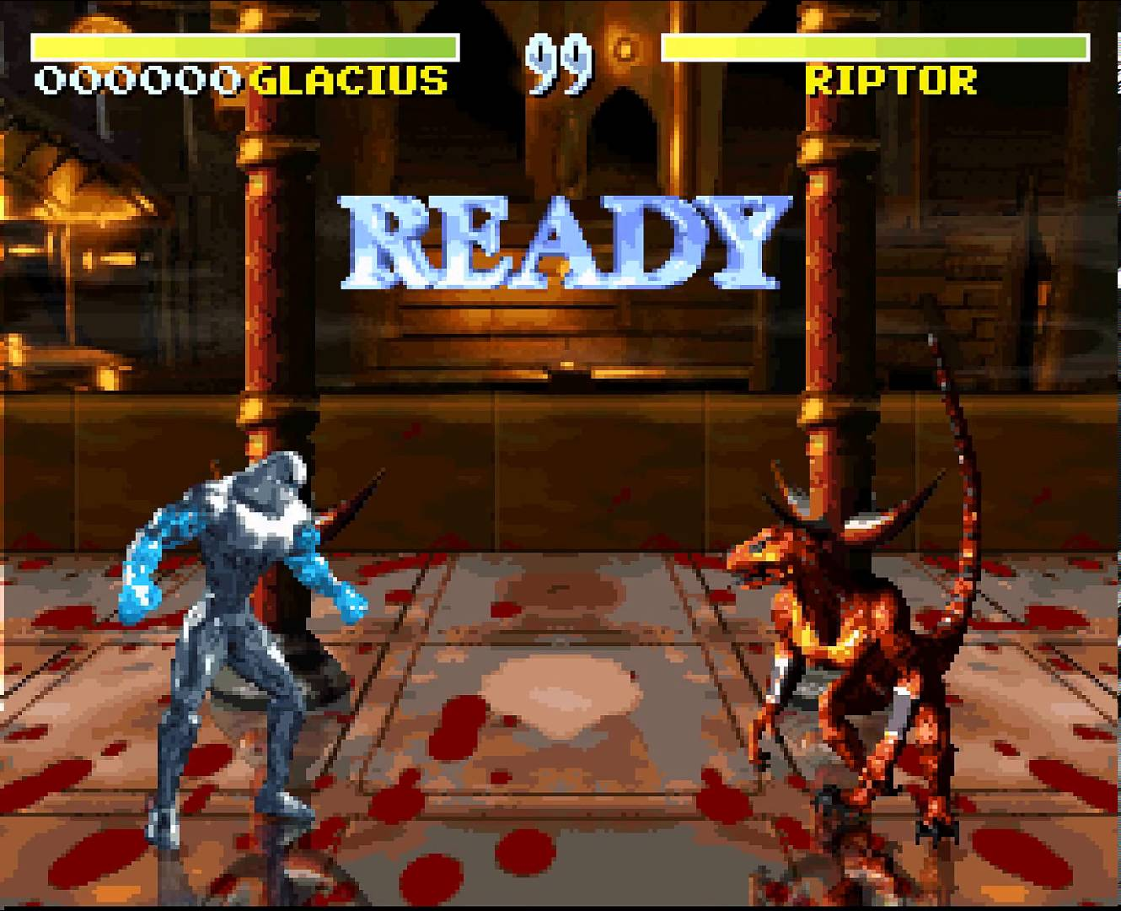

- (1990) Pit Fighter
https://www.youtube.com/watch?v=PnFU-BXda2A
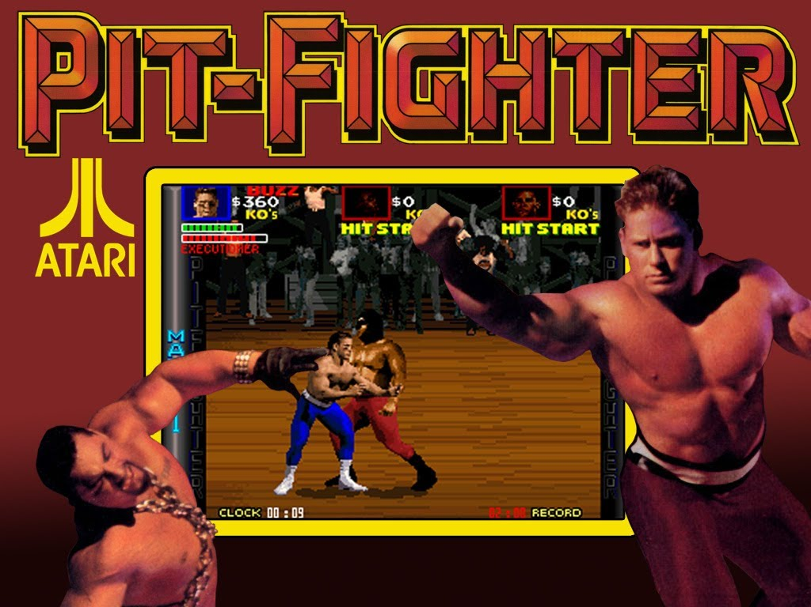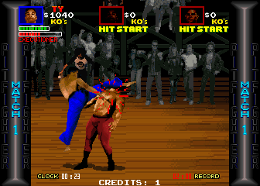

- (1992) Power Athlete (Power Moves)
https://www.youtube.com/watch?v=4x1VCDxSnlg
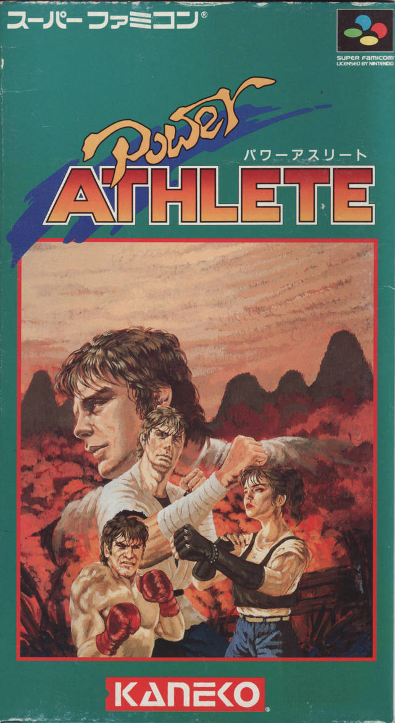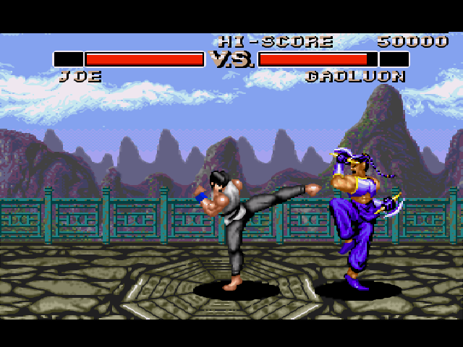
Power Athete! Maravilhoso! [Miguel]

- Hiruy No Ken: Golden Warrior - Gameplay - Wikipedia
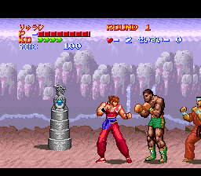

- (1994) Primal Rage
https://www.youtube.com/watch?v=PXlNJKfCmpQ
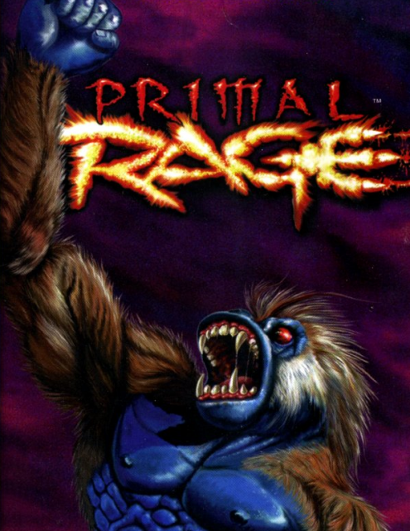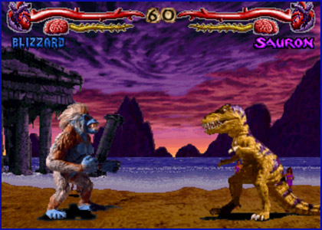

- (1992) Ranma 1/2
https://www.youtube.com/watch?v=sPpKHxuDIeY
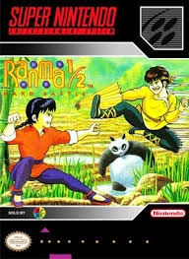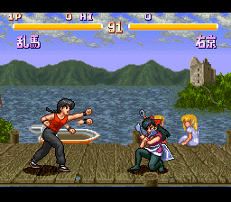

- (1994) Rise Of The Robots
https://www.youtube.com/watch?v=6bhyAZPsUIM
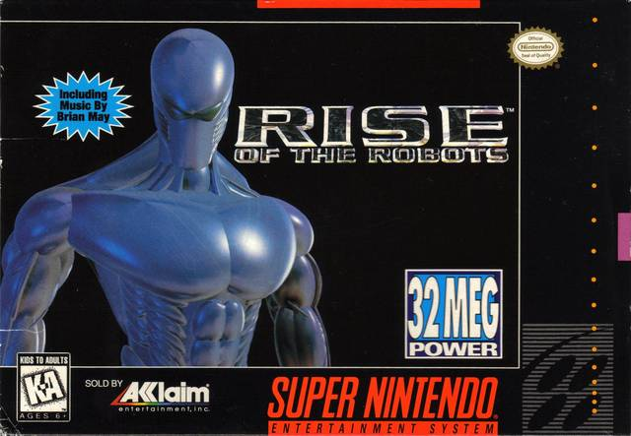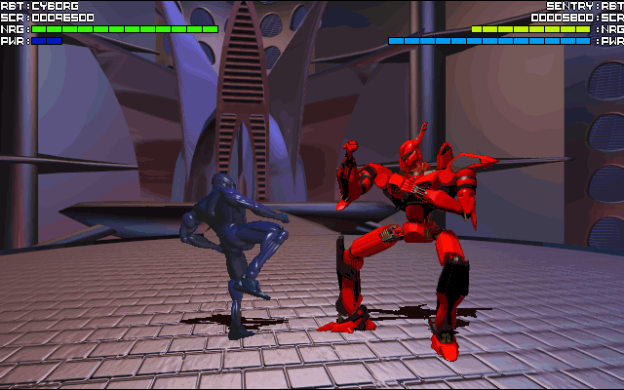

- (1994) Shaq Fu
https://www.youtube.com/watch?v=GsuXEJ6e87k
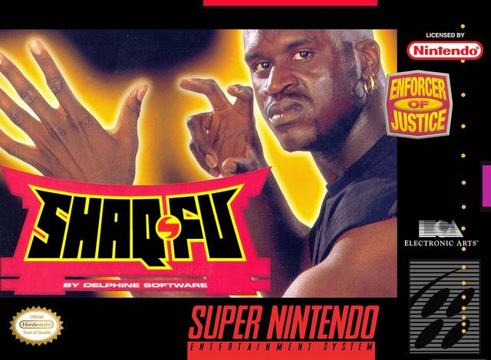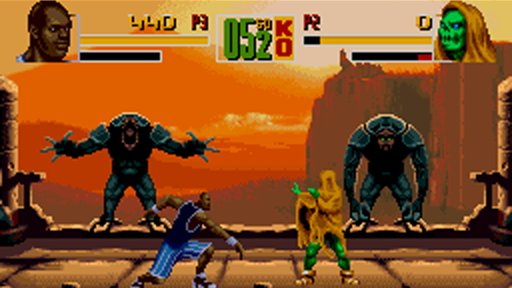

- (1994) Shaq Fu
https://www.youtube.com/watch?v=GsuXEJ6e87k

- (1995) Street Fighter The Movie
https://www.youtube.com/watch?v=t4UdQVYkCZg
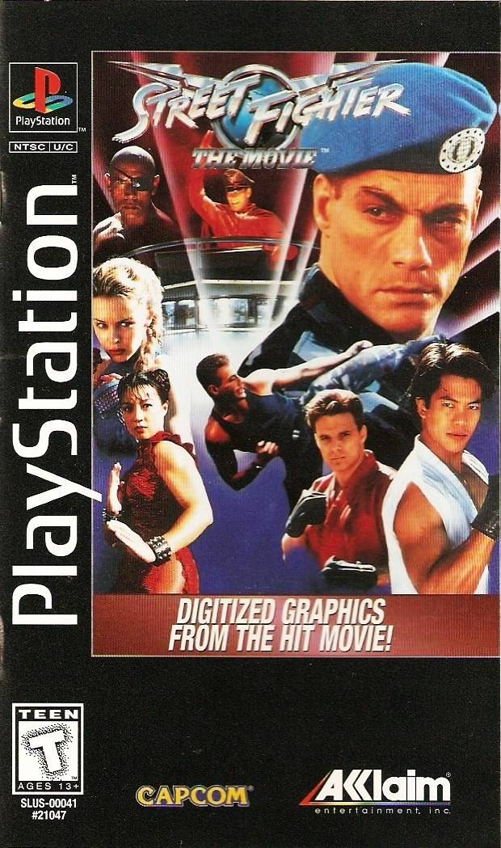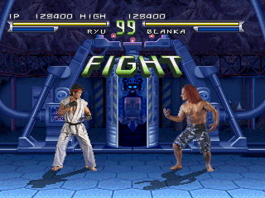

- (1995) Street Fighter The Movie
https://www.youtube.com/watch?v=t4UdQVYkCZg

- (1993) Turtles Tournament Fighters
https://www.youtube.com/watch?v=T9_hFLrG7As
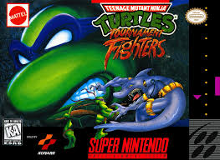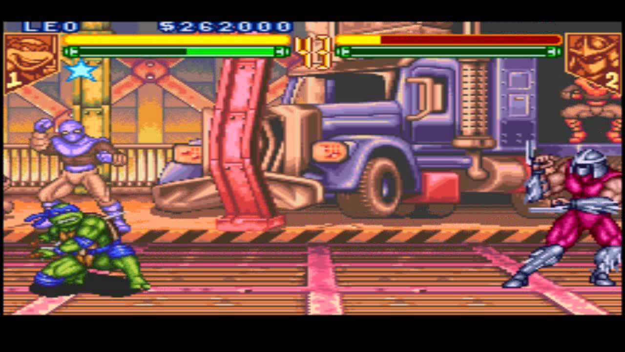

- (1991) Ultraman
https://www.youtube.com/watch?v=tJH7FMBl8BM
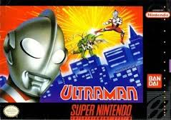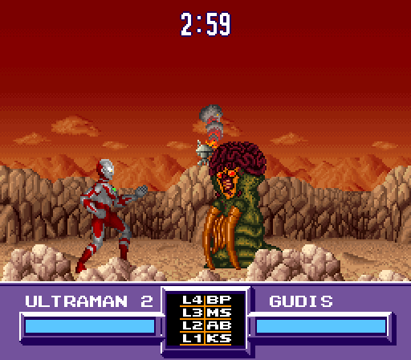

- (1992) World Heroes
https://www.youtube.com/watch?v=x4dBw-js8dU
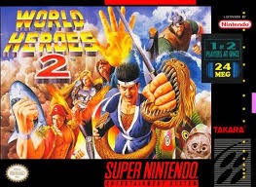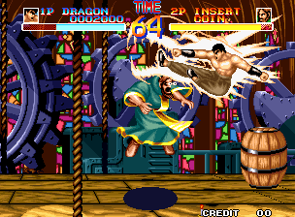

- (1994) WWF RAW
https://www.youtube.com/watch?v=V5pmZ7tKB5o
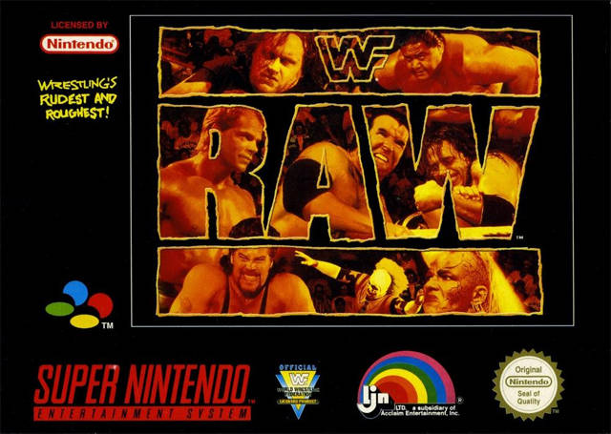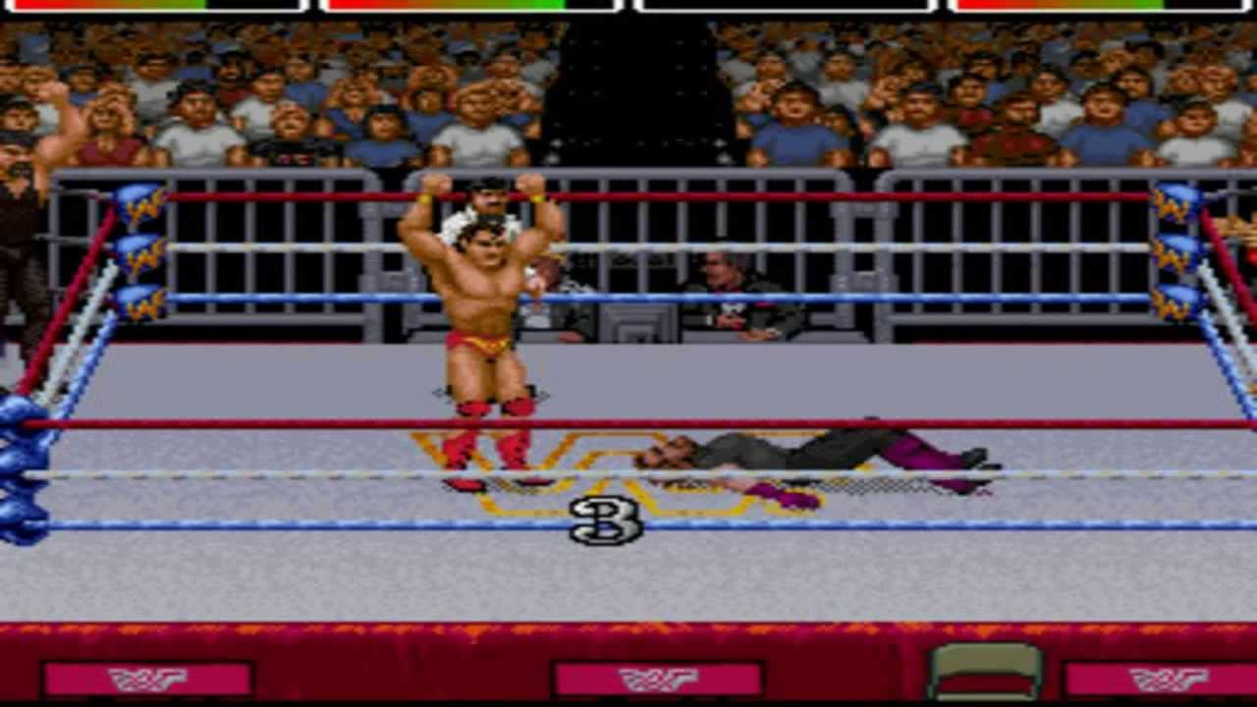

- (1992) Astral Bout
https://www.youtube.com/watch?v=yVmyRzX1J6M
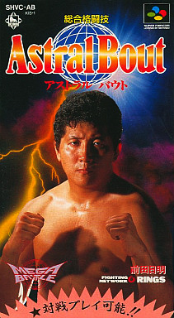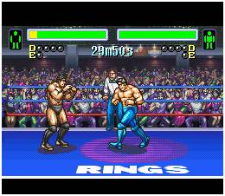

- (1989) Streetsmart
https://www.youtube.com/watch?v=WixkAjaUzZU

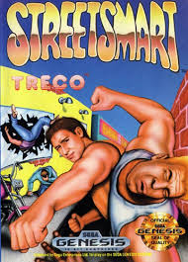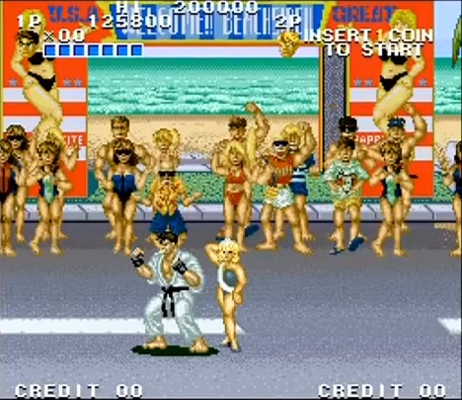

- (1992) Best of the Best Karate Championship
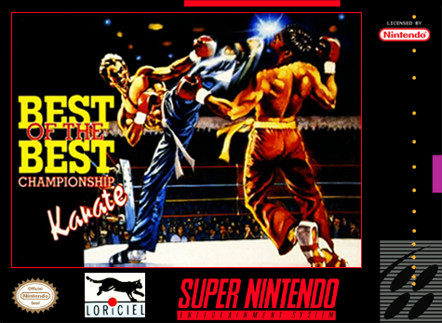
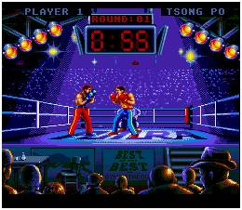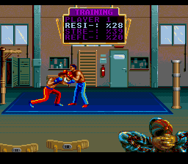
Youtube
Wikipedia

- (1991) Heavy Nova
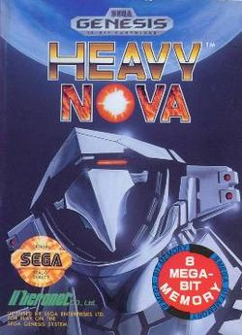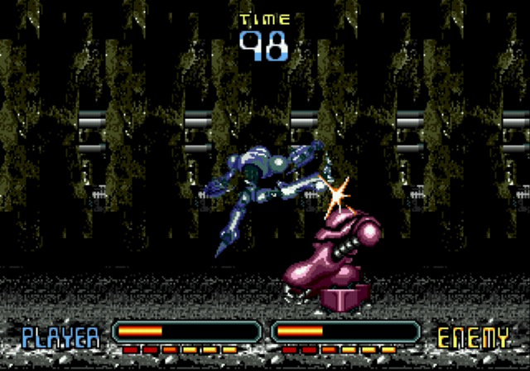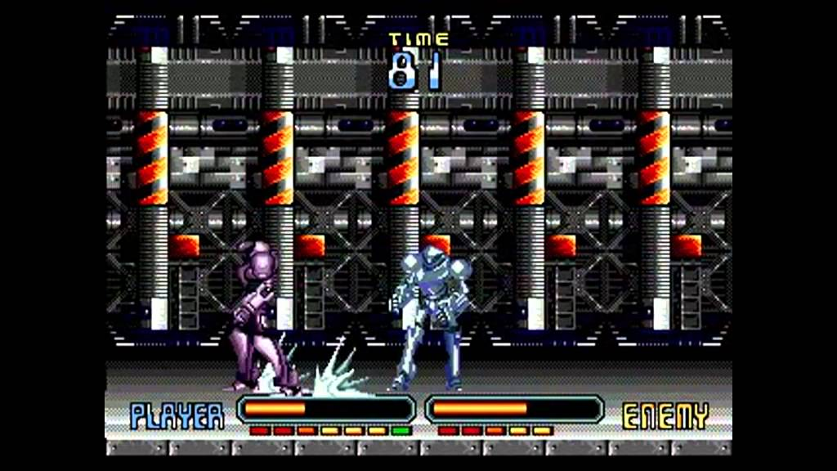
Youtube
Wiki

- (1993) Tuff e Nuff (Dead Dance)
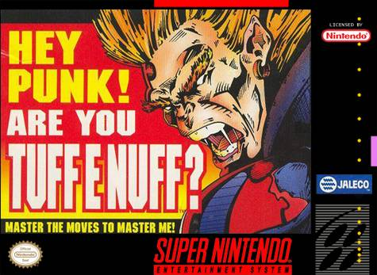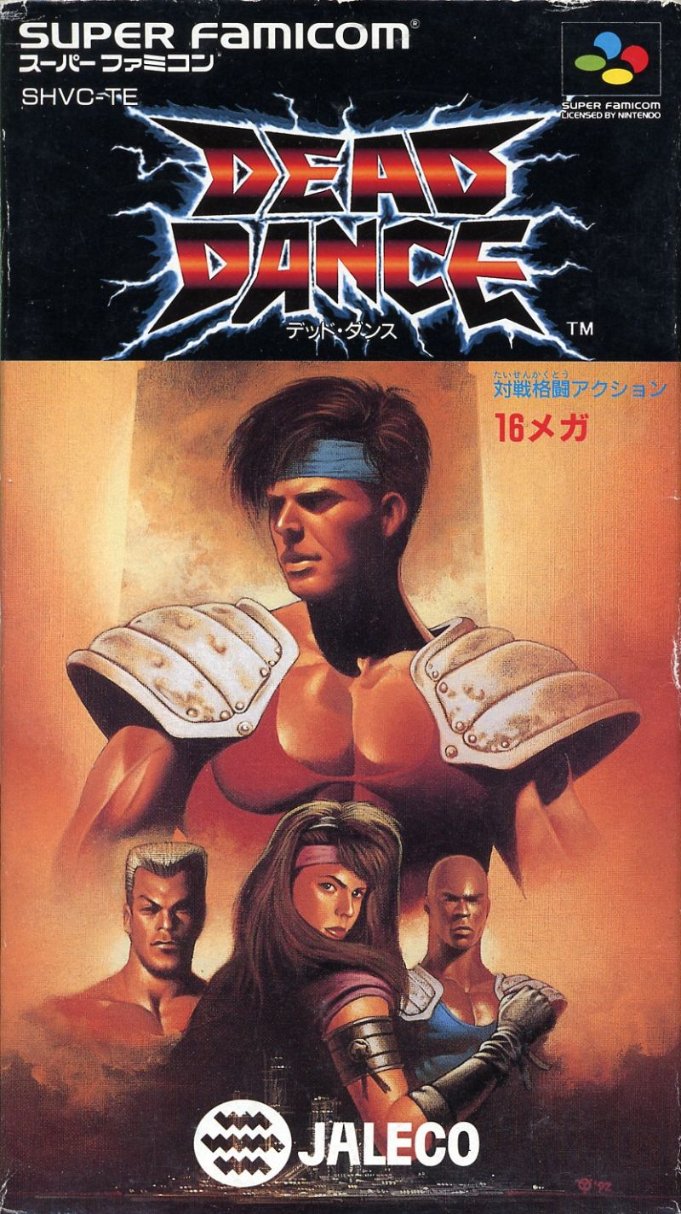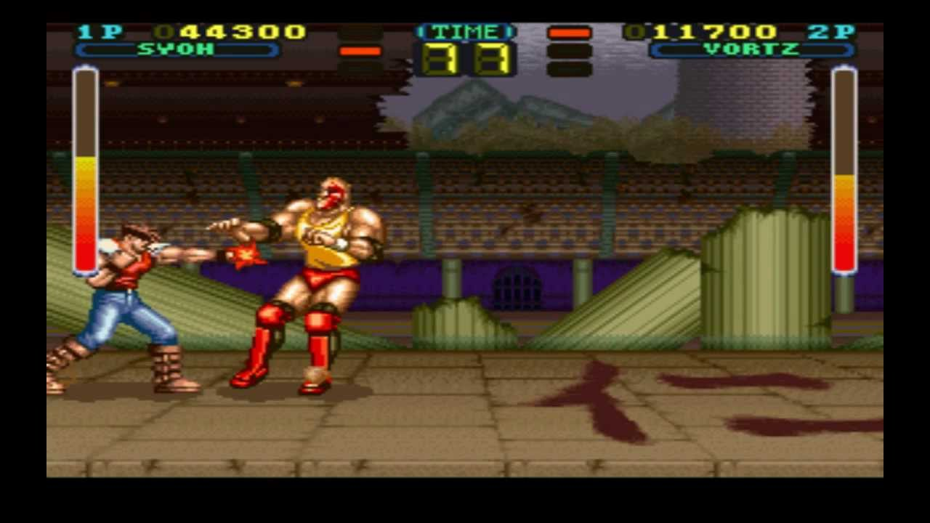
Dead Dance (Youtube)
Wikipedia
STREET CHAVES
https://www.youtube.com/watch?v=49elB8k2Od8

Encerramento
- Merchãs a vontade.

